1. Install VS Code using installer in C:\ => “VSCodeUserSetup-x64-1.68.1.exe”
2. Install target is in “C:\users\[PMI Account]”
3. Install Git library using installer in C:\ => “Git-2.37.0-64-bit.exe”
4. Create your code folder under “C:\SourceCode\Moses\”
5. Go to VS Code and Install Extension “Robot Framework Language” and “Robocorp Code”
6. Open Folder in VS Code to “C:\SourceCode\Moses\”
7. Go to Menu View, Command Palette or Ctrl + Shift + p and choose Robocorp: Create Robot
8. Wait a moment, bottom right will show error lock (you can just ignore)

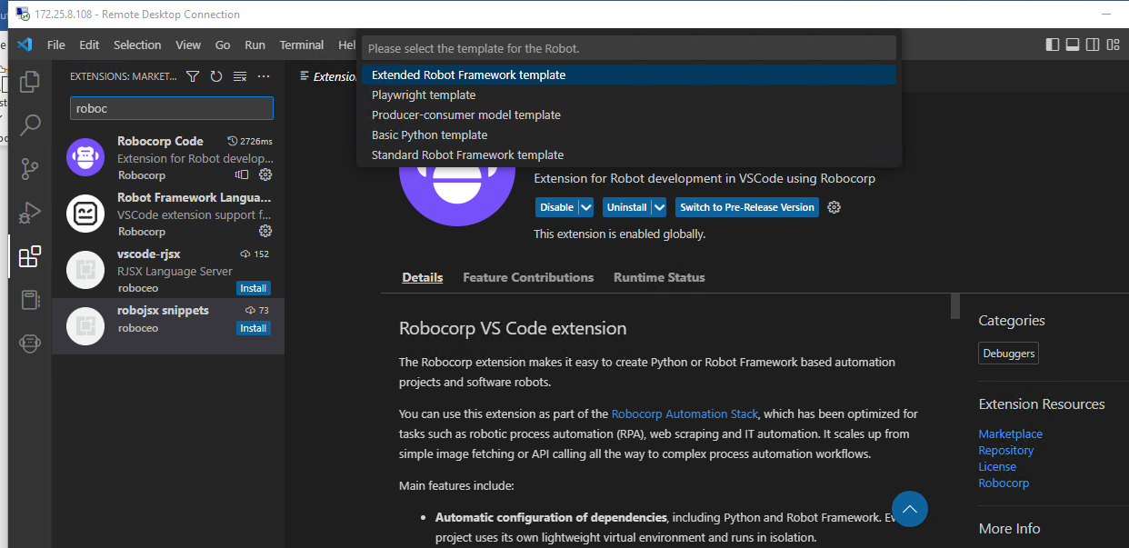

1. Choose “Standard Robot Framework template”
2. Choose “Use Workspace Folder”
3. Choose “Create Robot Anyways”
4. Files will be added, and message Robot Created successfully

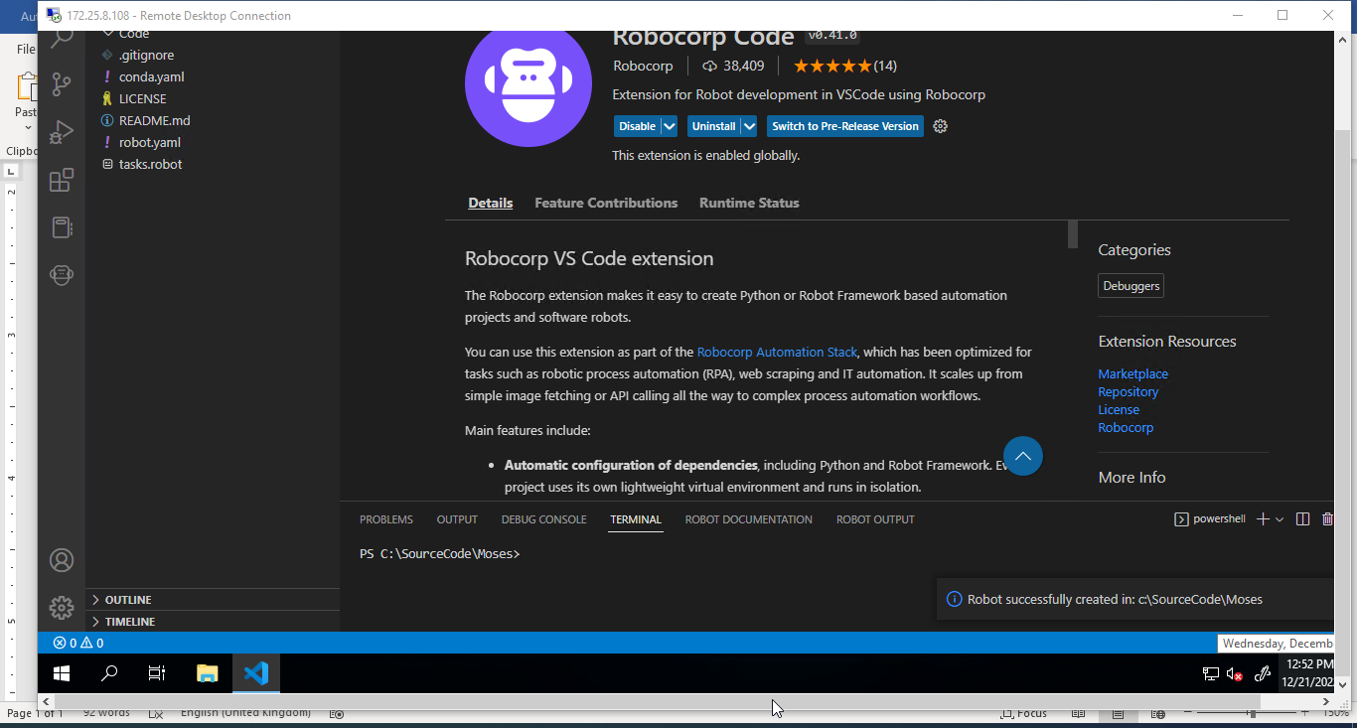

Bitbucket Development:

1. Install Extension “Jira and Bitbucket (Atlassian Labs)”
2. Go to Bitbucket Settings:

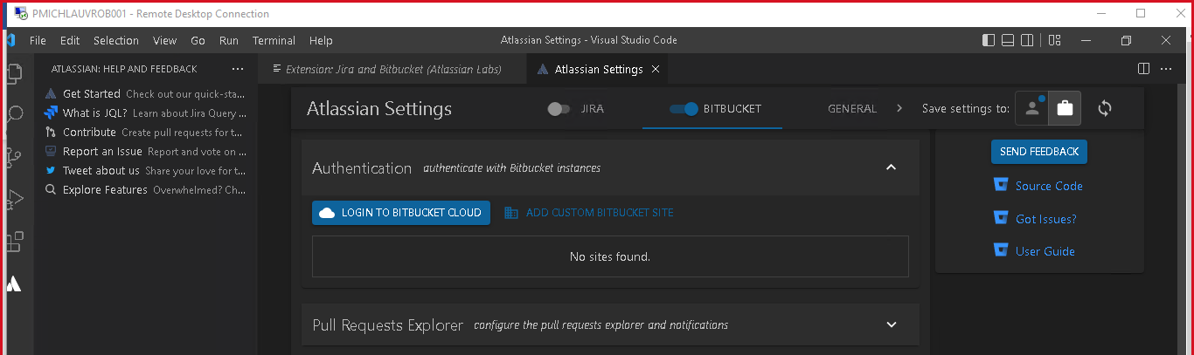

1. Add Custom Bitbucket Site
2. Input Custom URL: <https://source.app.pconnect.biz/>
3. Input Username: [mmoses2@PMINTL.NET](mailto:mmoses2@PMINTL.NET)
4. Input Password: Get from Bitbucket Token

* Via Bitbucket Web
* Go to My Account on Top Right
* Go to Http Access Tokens and Create Token; Token will be used as password

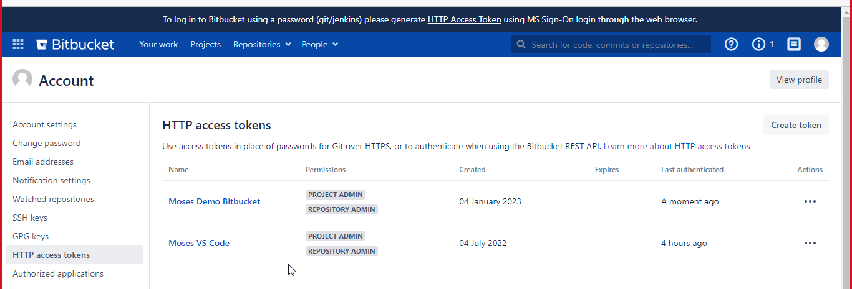

1. Afterwards, you go to Web Repository (existing): Choose Clone menu and take the URL

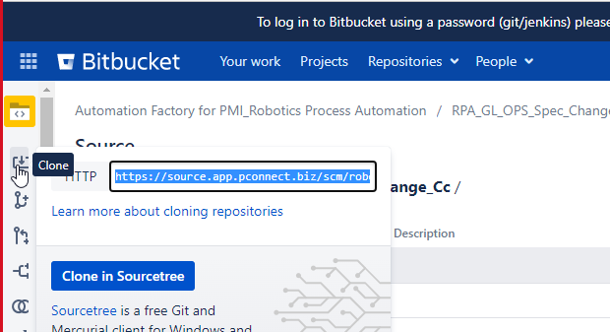

1. Go to menu View, Command Palette or Ctrl Shift P; and choose menu “Git: Clone”
2. Input URL from Step 7; Example <https://source.app.pconnect.biz/scm/robotics/rpa_gl_ops_spec_change_cc.git>
3. Choose Folder in your local source Code “C:\SourceCode\Moses\”
4. The Cloning process will be starting, and then you can start to code
5. (If Popup is appear), input again the username password from step 5 & 6